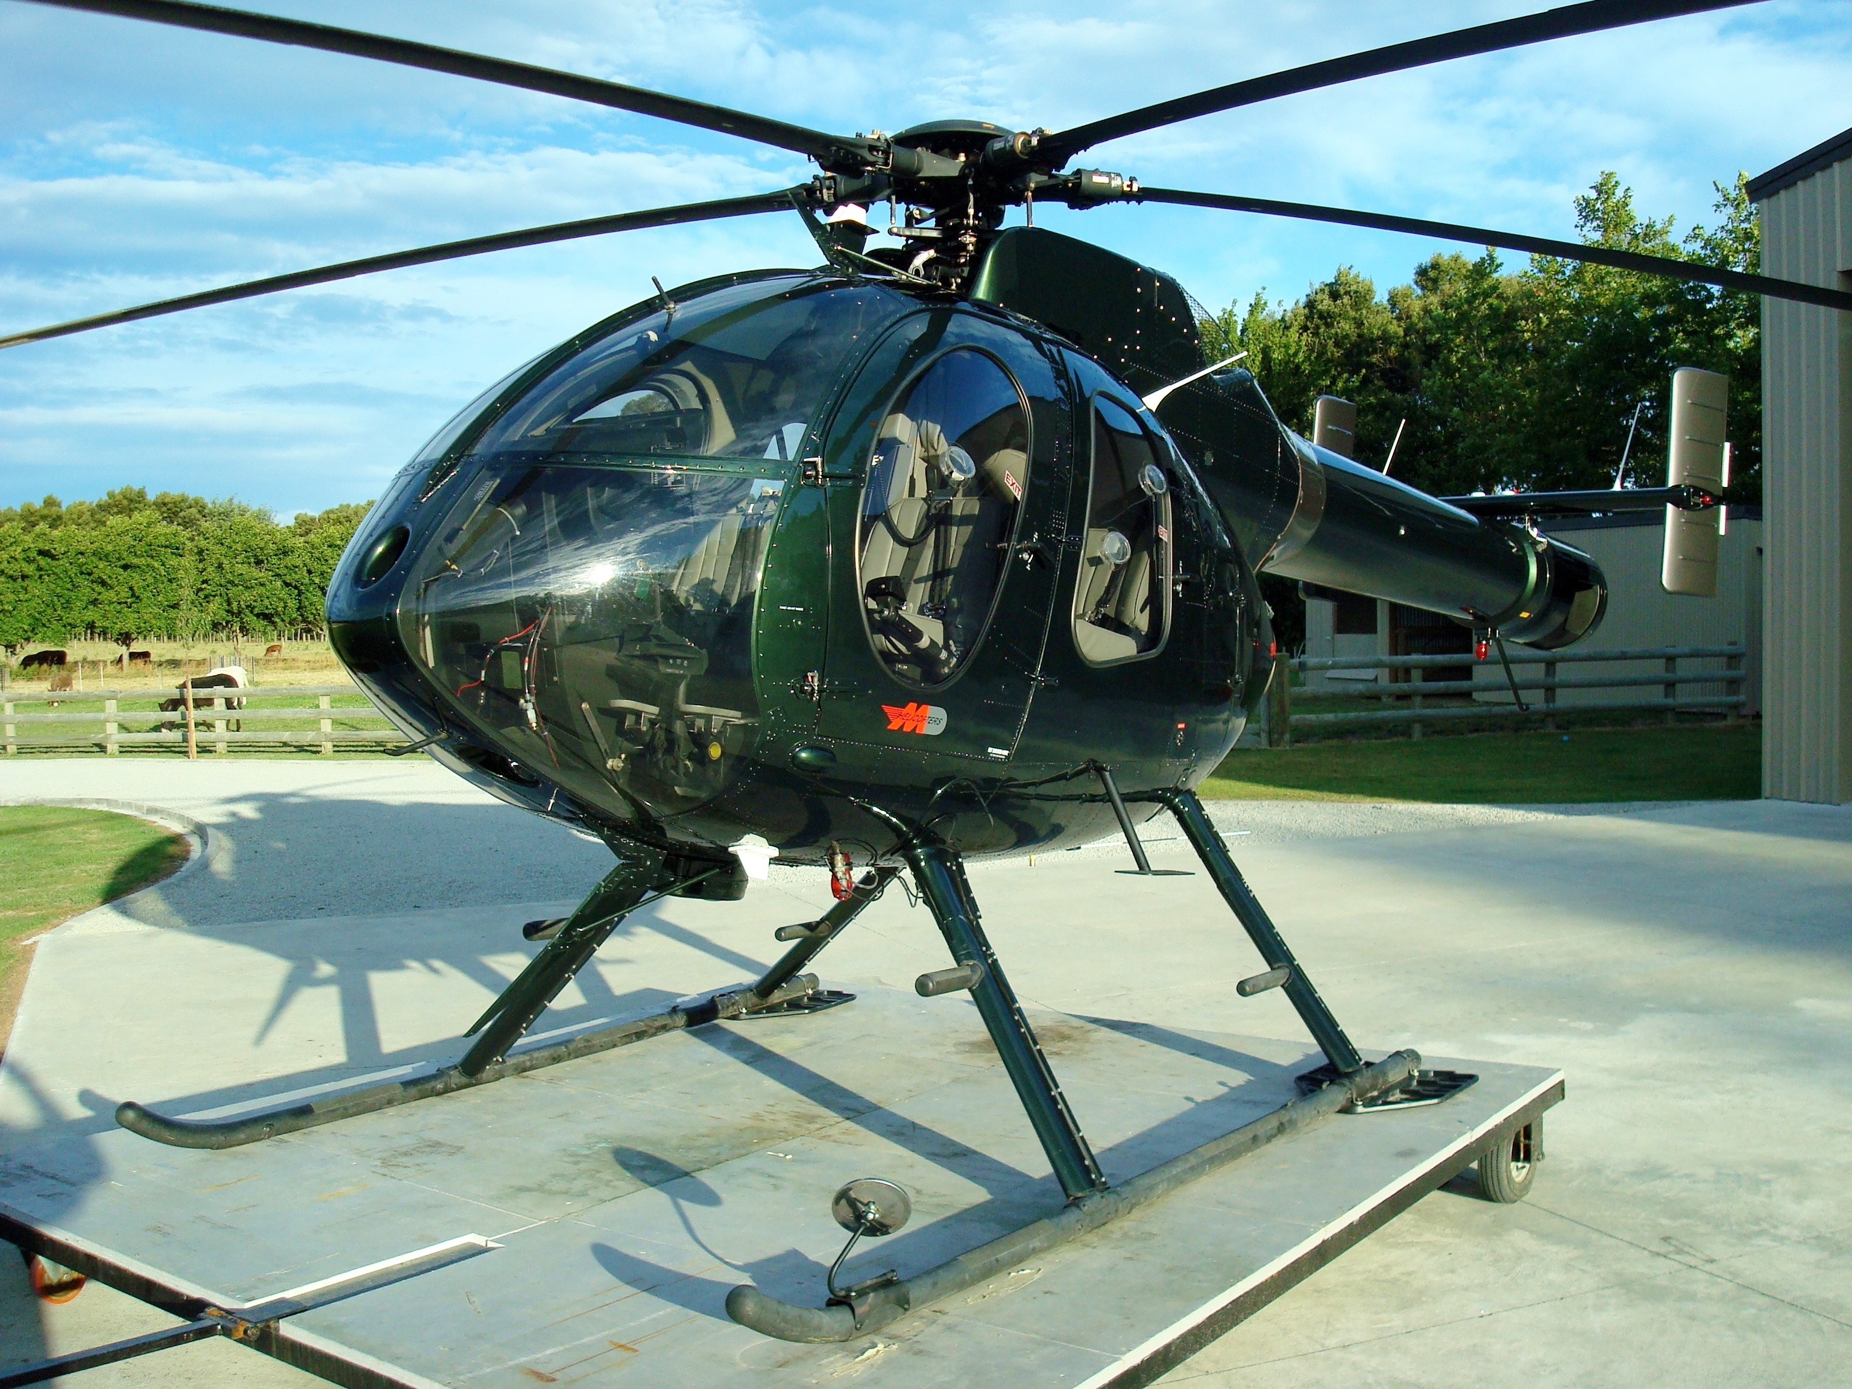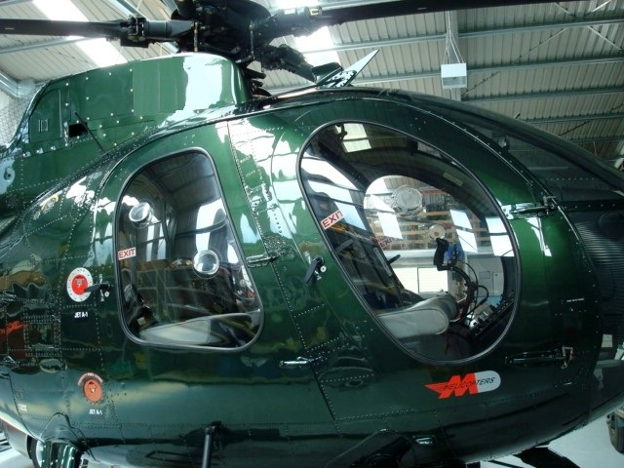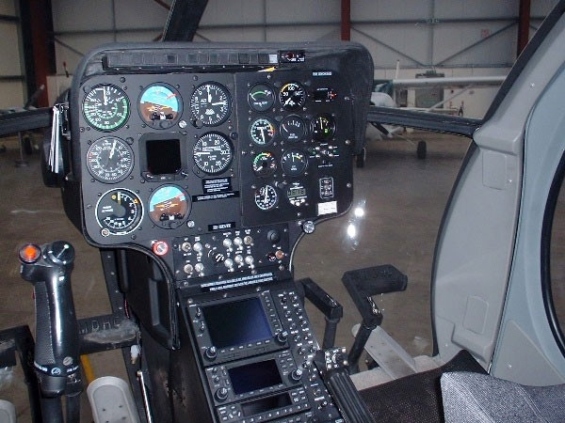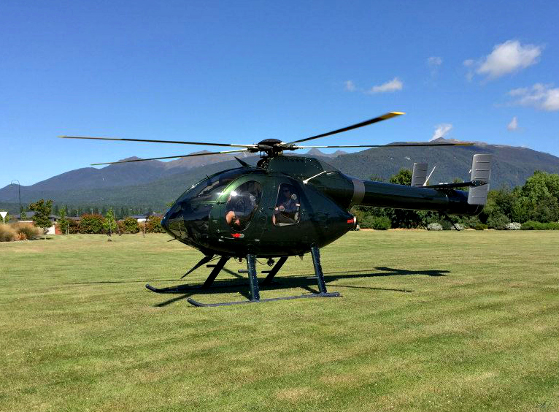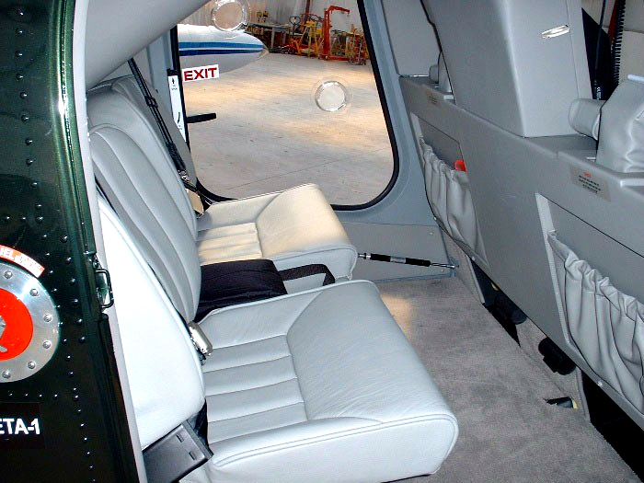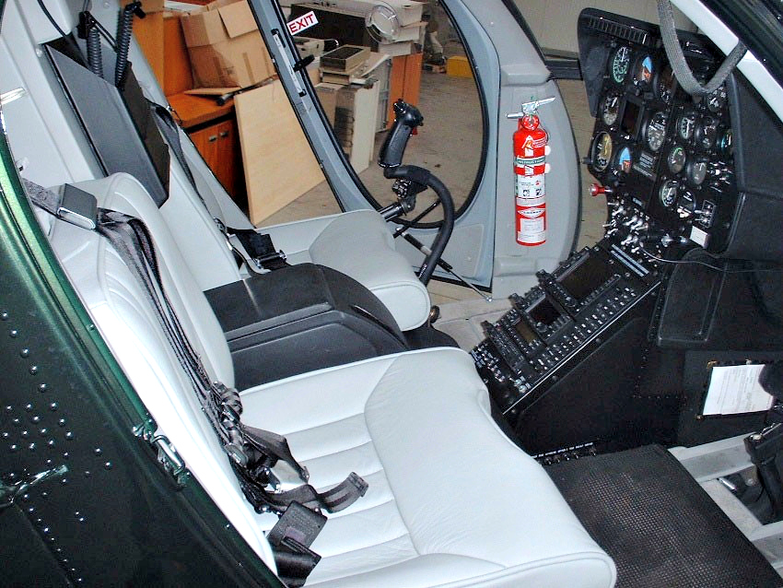­­­­­

**AVIONICS**

- Garmin GMA-340 Audio Panel  
- Garmin GNS-540 GPS/Comm  
- Garmin GNS-430 GPS/Comm  
- King KR87 ADF  
- Garmin GTX-327 Transponder  
- Ryan T-Cad Traffic System  
- GI102 Compass/KI 825 Indicator

- Tait 2010 VHF

- King KRA 10A Radop Altimeter

- 2 x Master Avionics Switch

**EQUIPMENT**

- C20R2 Engine

- High Skids

- Grey Leather

- Wire Strike Kit

- Heated Pitot

- Dual Controls

- Scavange Oil Filter

- Slant Panel

- Bleed Air Defogger

- Auto Relight

- Rotor Brake

- Particle Separator

- Cargo Hook & Skid Mirror

- Night Scanner Light

- Engine Fire Detection System

- Ground Handling Wheels & Tie Downs

**AUSTRALIA**

**Chris Wolff**

Aviation Sales & Service

221 Qantas Avenue

Archerfield Airport

Queensland, Australia 4108

**P** +07 3875 2999

**M** +0418 782 862

**E**  sales@aviationsales.com.au

**W** aviationsales.com.au

**NEW ZEALAND**

**Stephen Boyce**

Sales Manager | Pilot

1 Harvard Lane

Ardmore Airport

Auckland, New Zealand 1022

**P** +64 9 296 2644

M +64 21 540 460

**E** stephen@ohl.co.nz

**W** oceania-aviation.com

Make & Model:   
**MD520N**

Manufactured:   
**1999**

SERIAL NUMBER:   
**LN0XX**

A/C Total Time:

**564 hours**

LOCATION:  
**NEW ZEALAND**

PRICE:   
USD $ 1,100,000

+ GST if Applicable